**Wireframe Document**

**Amazon Sales Data**

**Revision Number - 1.2**

**Last Date of Revision - 14/09/2022**

**Kanishka Kumar**

WIREFRAME DOCUMENT DESIGN

**Document Control**

|  |  |  |  |
| --- | --- | --- | --- |
| **Date** | **Version** | **Description** | **Author** |
|  |  |  |  |
| 05/08/2022 | 1.0 | Introduction, | Kanishka Kumar |
|  |  | Problem Statement |  |
|  |  |  |  |
| 18/08/2022 | 1.1 | Dataset Information, | Kanishka Kumar |
|  |  | Architecture |  |
|  |  | Description |  |
|  |  |  |  |
| 14/09/2022 | 1.2 | Final Revision | Kanishka Kumar |
|  |  |  |  |



**Introduction& Problem Statement**

Sales management has gained importance to meet increasing competition and the need

for improved methods of distribution to reduce cost and to increase profits. Sales

management today is the most important function in a commercial and business

enterprise.

To understand the sales trends –

This dataset contains sales of the product and we have to find -

Month vs sales trends

Year vs sales trends

Month year vs sales trends

Find key metrics and factors and show the meaningful relationships between attributes.

Do your own research and come up with your findings

I

WIREFRAME DOCUMENT DESIGN

**We Performed Exploratory Data Analysis on Jupyter Notebook and then created a Tableau Dashboard.**

1. **Number of Column**

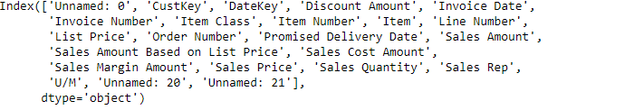

1. **Total Data in Dataset –**

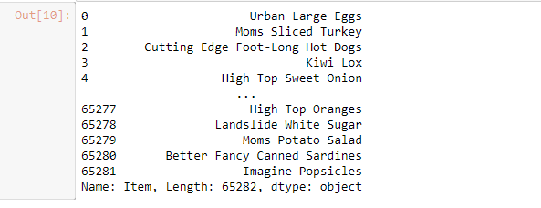

1. **Data for Years in Dataset –**

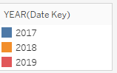

**DashBoard :**

1. **Month vs Sales :-**

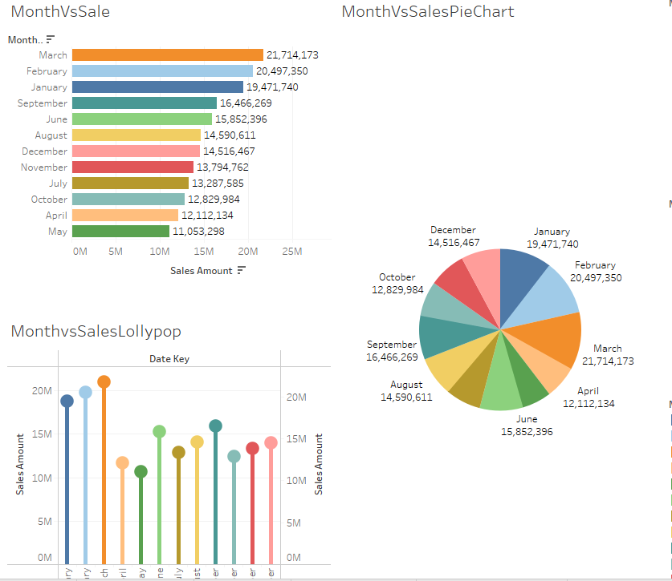

1. **Years Vs Sales –**

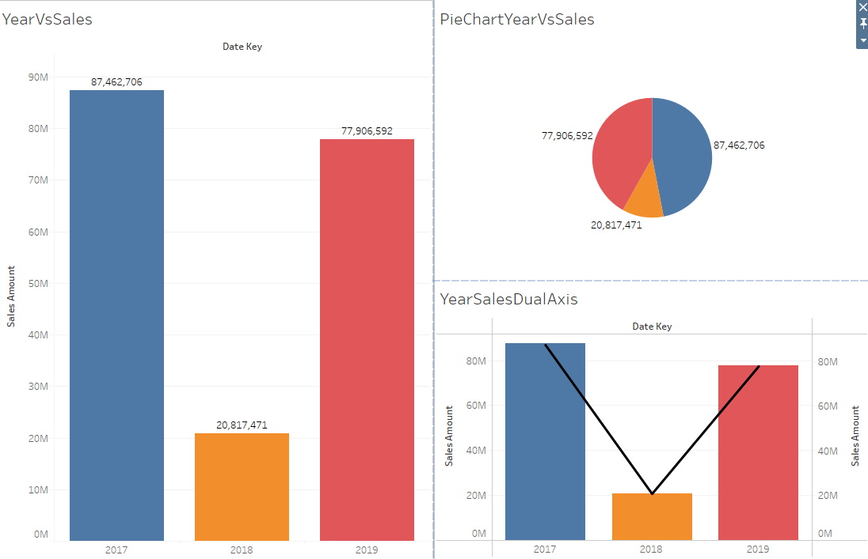

1. **Month Years Vs Sales :**

